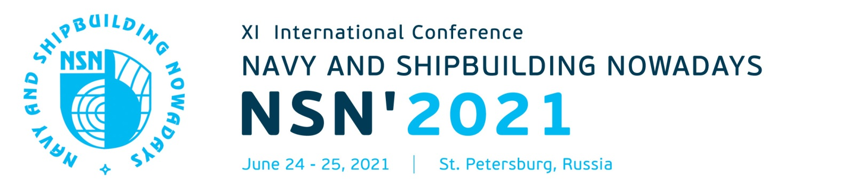

Declaration of Interest

Complete the following. Please type or print clearly and return this form by E-mail to:

NSN’2021 Secretariat
Krylov State Research Centre
44 Moskovskoe Shosse, St.Petersburg, 196158, Russia
E-mail: nsn@ksrc.ru , A_Pylaev@ksrc.ru
Tel.: (812) 748-6347, (812) 386-6716 Fax: (812) 727-9594

Mrs. Mr. Prof. Dr.
Surname
First Name(s)
Position
Company (organization)
Postal address
City with postal code Country
E-mail
Telephone Fax
Accompanying person(s):

I intend to participate in Conference Yes/No
I wish to submit a paper Yes/No

Signature _______________ Date ________________

Copies of this form you may distribute among your colleagues who might be interested in attending the NSN’2021. Also, we would be grateful if you give us contact information about interested persons, companies and organizations.

